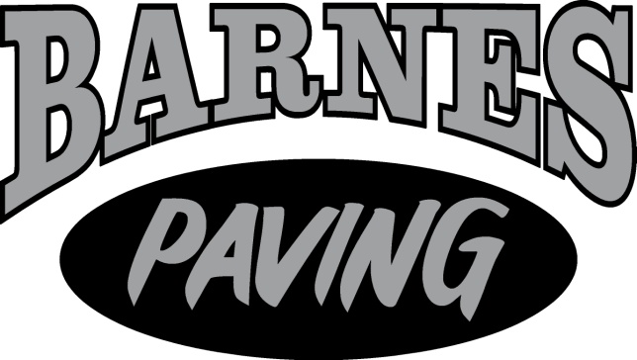

Barnes Paving is a local family owned and operated business right in the heart of Whiteford, MD.
Support your local businesses and call Barnes Paving for your next paving, excavating, or snow removal job!

Doug Barnes, Owner
443-243-3710
barnespaving@verizon.net

